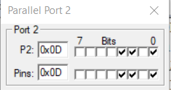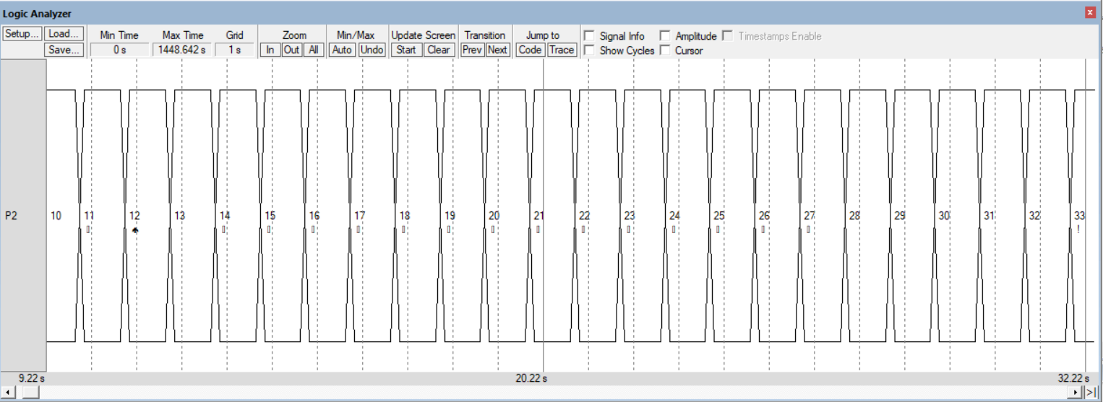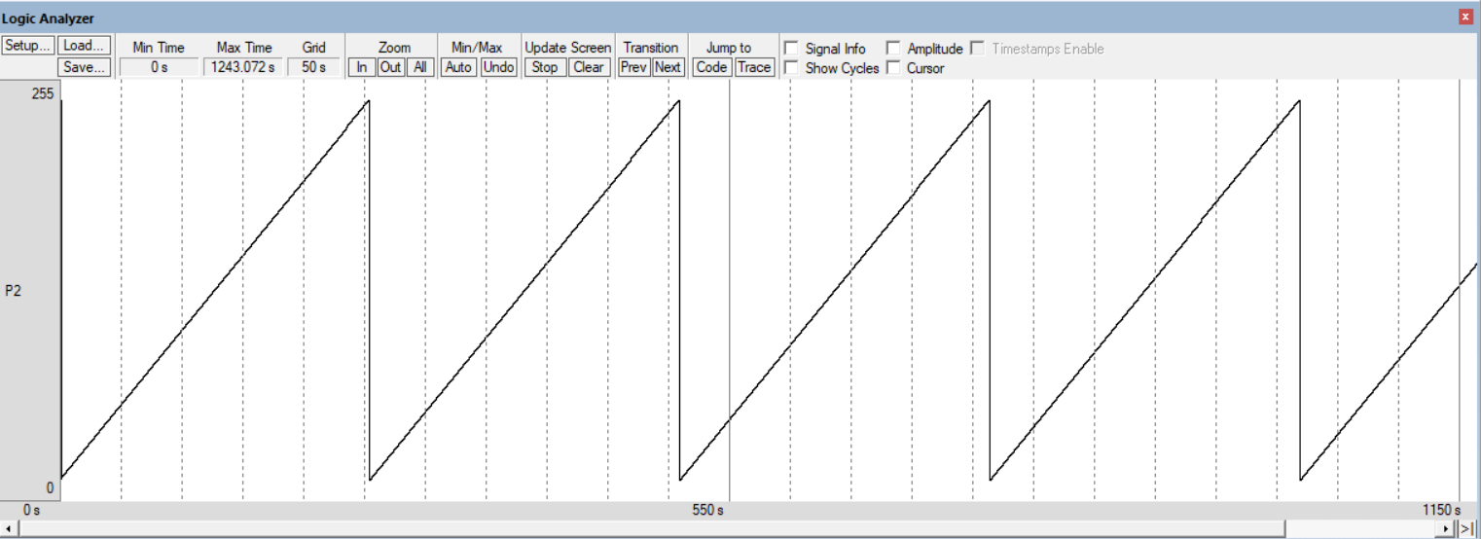EXPT2D: ALP FOR HEXADECIMAL NUMBER DISPLAY ON LEDS CONNECTED TO PORT 2

312041